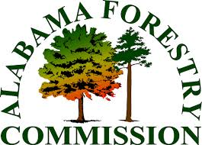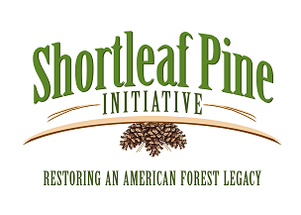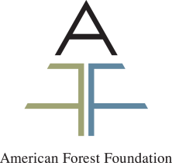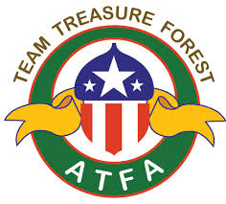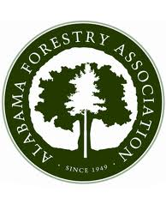

Shortleaf Pine Management  
North Alabama Agriplex Heritage Center  
1714 Tally Ho Street, SW Cullman, Ala.  
January 29, 2015

**Purpose:** Provide current information for making informed decisions regarding shortleaf pine as a viable species to meet landowner objectives and allow for discussion with resource professional’s personal experiences and questions.

**Professional Development:** SAF – 5 hours, Alabama CFE - 5 hours, Alabama PLM – 6 hours. Be sure to sign the appropriate sign in sheets and pick up your certificate before leaving.

**Registration:** Closed.

**Contact**: Chris Erwin, American Forest Foundation, 202-480-4038 or [cerwin@forestfoundation.org](mailto:cerwin@forestfoundation.org).

8:30 Silvics of Shortleaf Pine, Even and Uneven Aged Management – Ed Loewenstein, Auburn University

10:30 Break

10:50 Role of SLP in Mitigating Risk – Mathew Smidt, Auburn University

11:20 Soil and Landform Impacts on Shortleaf – Lawrence McGhee, USDA NRCS

11:50 Catered Lunch Will Be Provided

12:30 Cost Share Opportunities – Murray Griffin, USDA NRCS Representative

1:00 Associated Plant Communities and Invasive Threats – Nancy Loewenstein, Auburn University

1:30 Shortleaf Pine Initiative – Mike Black, Shortleaf Pine Initiative

2:00 Shortleaf Pine on the Cumberland Plateau Project – Chris Erwin, American Forest Foundation

2:30 Evaluation and Adjourn

**Sponsors:** This program is made available by a grant from the National Fish and Wildlife Foundation’s 2014 Cumberland Plateau Stewardship Fund designed to accelerate the restoration and enhancement of critical forest and freshwater habitats and associated wildlife species in the region. Funding is provided by International Paper’s Forestland Stewards Initiative and USDA Natural Resource Conservation Service.

